World Tuberculosis (TB) Day (3/24)
Social Media Kit – Addendum
PURPOSE:
The purpose of this Social Media Kit is to help promote the upcoming World Tuberculosis Day (WTBD) Event taking place in San Francisco the morning of March 22, 2018 (actual WTBD is on March 24th). The event will help raise community awareness of the world’s leading infectious disease killer, and the control and prevention efforts being made to help end TB.
INSTRUCTIONS:
- Select desired message and post accordingly throughout the month of March
- BE SURE TO ADD AN IMAGE!
HELPFUL TIME-SAVING TIPS:
Hootsuite: Hootsuite is a social media management platform that allows you to save time by scheduling posts in advance. Hootsuite offers a free plan that inputs up to 30 messages at a time for up to 3 social media platforms. Create a free account at www.hootsuite.com.

CONTACT US ABOUT THE EVENT:
California Tuberculosis Controllers Association
Website: www.ctca.org
E-mail: jthigpen@ctca.org
Facebook: www.facebook.com/CaliforniaTuberculosisControllersAssociation
Twitter: @CTCAzeroTB
Breathe California Golden Gate Public Health Partnership
Website: www.ggbreathe.org
E-mail: audreya@ggbreathe.org
Facebook: www.facebook.com/BreatheCaliforniaGG
Twitter: @BreatheCAGGPHP

General messages to add this month:
- Today we highlight the unique story of Reina Whitney, TB Survivor and Former Patient of the Vauclain Home Sanatorium, San Diego, CA http://ow.ly/90G730iQfWQ #WorldTBDay #TBfreeCA #tbsurvivor #tbstories #EndTB @CTCAzeroTB @StopTB @TBControllers
- Do you know your #TBrisk? Check our Self-Assessment Sheet http://ow.ly/ilCA30iQg3m #WorldTBDay #TBfreeCA #EndTB @CDC_TB @CTCAzeroTB @StopTB @TBControllers
- Do you know the signs of #tuberculosis? Learn about TB symptoms by checking our TB Symptoms Sheet http://ow.ly/7WFe30iQfZC #WorldTBDay #TBrisk #TBfreeCA #EndTB @CDC_TB @CTCAzeroTB @StopTB @TBControllers
- #ForTheDoc: Check out these helpful TB resources http://ow.ly/7WFe30iQfZC #WorldTBDay #TBfreeCA #EndTB @CDC_TB @CTCAzeroTB @StopTB @TBControllers
- #ForTheDoc: Review population-based risk assessments designed to identify those that have higher risk for TB infection http://ow.ly/VDrV30iQfVo #WorldTBDay #TBrisk #TBfreeCA #EndTB @CDC_TB @CTCAzeroTB @StopTB @TBControllers
SF: Throughout March:
- World Tuberculosis (TB) Day is March 24th! To commemorate this global awareness day, we will be taking part in a World TB Day Walk on March 22 in San Francisco and lighting City Hall in red on 3/24 #WorldTBDay #TBfreeCA
- On Thursday, March 22nd, we will be participating in the World Tuberculosis Day Walk in San Francisco to commemorate #WorldTBDay (March 24) and raise awareness of the world's leading infectious disease killer #TBfreeCA #EndTB
- World TB Day is coming up on March 24th. What are you doing in your community to help #EndTB? In San Francisco, TB partners, patients, and members of the community will gather to raise awareness of the world's leading infection disease killer #TBfreeCA #EndTB #WorldTBDay
- On March 24th, please join TB partners, patients, and members of the community in raising awareness of the world's leading infection disease killer in commemoration of #WorldTuberculosisDay! #TBfreeCA #EndTB
World TB Day is one week away (3/17):
- World Tuberculosis (TB) Day is one week away! It’s an opportunity to mobilize and make a commitment to #EndTB. Join TB control partners and patients in raising awareness on March 24 by sharing facts or stories using the hashtag #TBfreeCA! #WorldTBDay
SF WTBD EVENT is three days away (3/19):
- The #WorldTBDay walk in San Francisco is only three days away! More TB awareness is needed to help one day create a #TBfreeCA and #EndTB around the world!
SF WTBD EVENT is one day away (3/21):
- Join us for the #WorldTBDay San Francisco Walk tomorrow along our route between 10-Noon. Don’t forget to apply the #TBfreeCA snapchat filter! Note for walkers: Always follow the rules of the road #TBfreeCA #EndTB
SF Day of WTBD EVENT (3/22):
- TODAY we’re commemorating #WorldTBDay (3/24) in SF with a walk to #EndTB - spreading awareness of the world's leading infectious disease killer. Join us out there between 10-Noon! Use the #TBfreeCA Snapchat filter and tweet us your post! Walkers: Follow the rules of the road.
- Follow us on social media all morning long as we commemorate #WorldTBDay (3/24) with a presentation and walk through SF. Take part in spreading awareness, on the route from 10-Noon or virtually. Be sure to use our Snapchat filter and post using #TBfreeCA! Together, we can #EndTB!
“World TB Day” and “End TB” image options (save onto computer and attach to social media post):
https://www.cdc.gov/tb/worldtbday/resources.htm

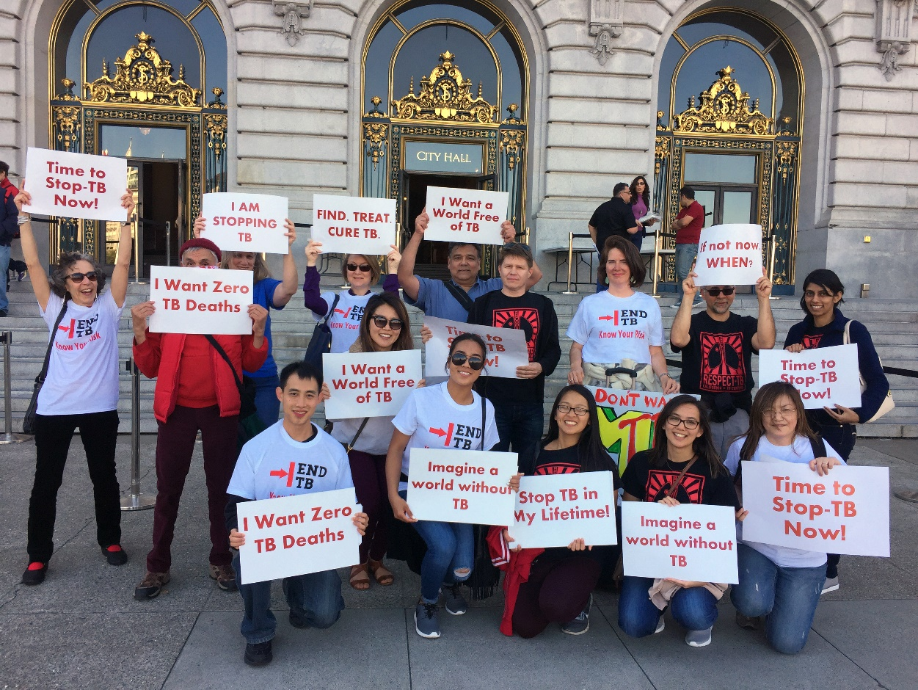
Great photos from previous walks:

