MARCH 22, 2018: WORLD TUBERCULOSIS DAY
California Tuberculosis Controllers Association with
San Francisco Department of Public Health
Ceremony & Third Annual SF Walk to End TB

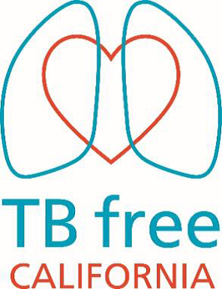
Please join the San Francisco Department of Public Health Tuberculosis Control (SFDPH) in celebrating World Tuberculosis Day.

This year’s theme for World Tuberculosis Day was adapted from the global stop TB partnership: “Celebrating Leaders for a TB Free World.”

We will honor North East Medical Services (NEMS) for their leadership in TB prevention. After this event, we will lead the 3rd Annual SF Walk to End TB, walking from NEMS Pacific Clinic to the Ferry Building.
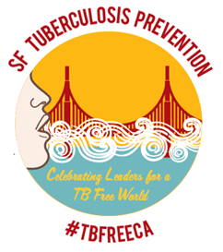
- What: Ceremony celebrating NEMS
Speakers: Dr. Chris Keh (SFDPH), Dr. Jennifer Flood (CDPH), Dr. Jerry Jew (NEMS), Tanya Stevenson (Breathe California Golden Gate)

- Where: NEMS Pacific Clinic 728 Pacific Ave, Floor 2, San Francisco 94133

- When: Thursday, March 22, 2018
Ceremony, 9:00am –10:00am “SF Walk to End TB”, NEMS to Vaillancourt Fountain near Ferry Building, 10:30 – 11:00 AM
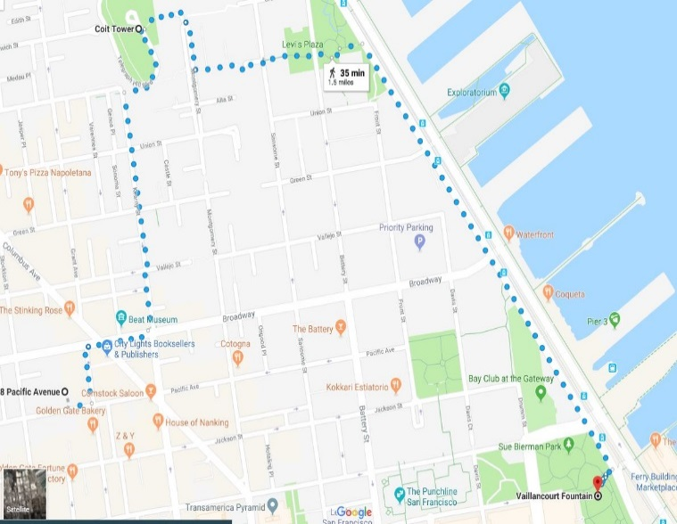
Logo Design by Freelance Designer, Marie Hunkele. Linked In Email: designmuse@mac.com

SF City Hall will join the yearly global initiative “Light up the World for TB” and be lit red on March 24th, 2018 in observance of World TB Day

Walk Route: 35 minutes, 1.5 miles
Start of Route: NEMS Pacific Clinic
End of Route: Vaillancourt Fountain near Ferry Building

Contact Judith Thigpen at the California TB Controllers Association, www.ctca.org with questions about the walk.

