WORLD TB DAY
TOOLKIT

Introduction

- Timing of Posts

- Theme and Key Messages

- Light Up the World Campaign

- Additional Resources

- About the California TB Controllers Association (CTCA) Communications Committee

www.ctca.org #WorldTBDay

INTRODUCTION
World TB Day is recognized every year on March 24th to commemorate the date in 1882 when Dr. Robert Koch discovered the TB bacteria. This toolkit outlines the theme and messaging for the 2021 World TB Day campaign, including visual assets, statistics and relevant links, to engage the community at-large and medical providers about TB.

World TB Day awareness and media activities aim to raise awareness about TB, that it is still a serious public health threat around the world and is still found in California.

TIMING SOCIAL MEDIA POSTS

Deciding which messages to share, which channels to use, and when to post messages will be different for every organization, depending on permissions to post and the number of channels available to you.

You can post all of the messages on the next page the week of World TB Day, March 24, through all channels you have access to, or you can spread them out before, on, and after World TB Day.
Please adapt the following messages as needed to meet guidelines for your organization. For more information, contact your organization’s Communications Department or Public Information Department.

Tip: Include #WorldTBDay #EndTB #TBfreeCA Participation is key to the success of the campaign.

THEME AND KEY MESSAGES
World TB Day is highlighted each year to engage health professionals, TB advocates, media, general public and government organizations in the fight against TB.

The 2021 World TB Day theme is “The clock is ticking.”

Key Messages and Target Audience:

General Public:
Like #COVID19, #tuberculosis (TB) is a life-threatening airborne disease that spreads from person to person. Today 2 million Californians are living with TB infection and most don’t know they have it. At any point, TB infection can become TB disease. #WorldTBDay #EndTB #TBFreeCA

Like #COVID19, #tuberculosis (TB) patients go through isolation, fear, discrimination and stigma. We CAN prevent TB disease in California by treating those with TB infection. No one has to suffer with TB disease. We can #EndTB once and for all! #WorldTBDay #TBFreeCA

Healthcare Worker:
Healthcare workers are at the center of the fight against diseases like #tuberculosis (TB) and #COVID19. #WorldTBDay is a time to thank our healthcare workers for all they do to keep our communities safe, remembering to think about TB when evaluating for COVID19. #EndTB #TBFreeCA

High-risk populations:
Unlike #COVID19, #tuberculosis (TB) infection can be found and treated before people get sick with TB disease. Some people are higher risk for TB infection. Know your risk for TB, know your TB status, and get treated to keep you and those around you safe. #EndTB #TBFreeCA #WorldTBDay

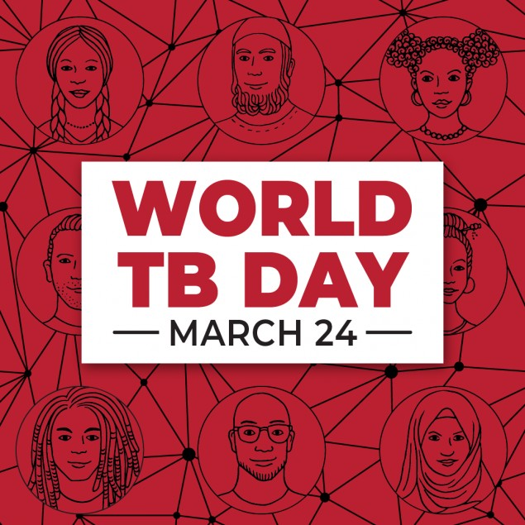

PIC TO POST WITH MESSAGES

More pics to post linked here.
https://www.cdc.gov/tb/worldtbday/Share_Rsrc.ht

LIGHT UP THE WORLD
The Light Up the World campaign asks landmarks across the world to light up in red on World TB Day. Landmarks across California are joining the campaign to show solidarity and bring light to this devastating disease that continues to affect our communities while honoring victims and survivors of TB. This is an opportunity to build public awareness that TB remains an epidemic in much of the world.
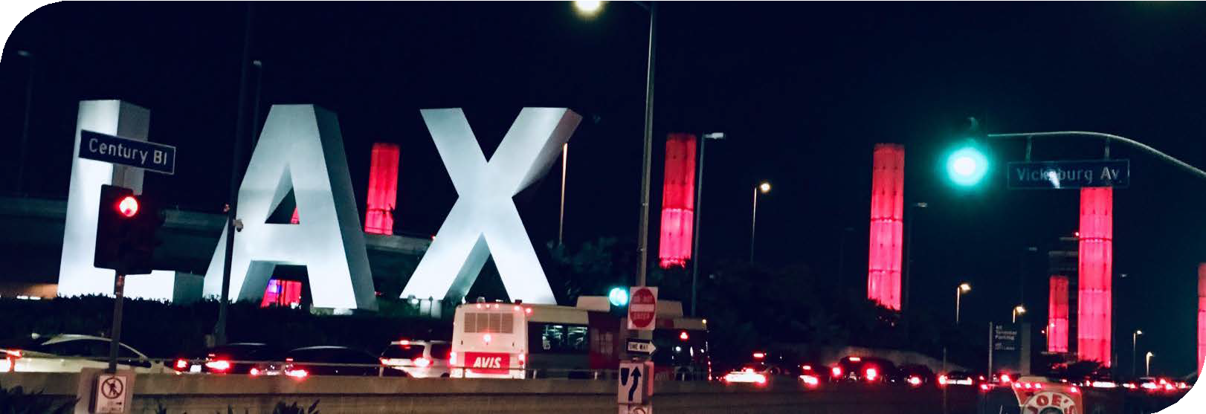
Join this campaign and share photos of these locations lit up in red to let your community know that TB is still a problem and there is work being done to eliminate it. Use #WorldTBDay on all social media posts.

ADDITIONAL RESOURCES

Community Resources
v Adult Self-Risk Assessment
v TB Educational Videos v What is TB infection? v What is TB disease? v Let’s Talk TB!

Provider Resources
v Adult Self-Risk Assessment
v Adult Self-Risk Assessment (for L.A. County use)

v TB Infection Treatment Information
v TB Infection Testing Information
v What is TB infection?
v What is TB disease?

ABOUT THE CTCA COMMUNICATIONS COMMITTEE
The CTCA Communications Committee plans and executes communication strategies to advance TB care and prevention in California. Its work supports TB programs in jurisdictions across CA by developing materials, disseminating information, and providing a home for the Coalition for a TB free California.

Contact us about the toolkit:
Website: https://ctca.org/toolkit
E-mail: jthigpen@ctca.org
Facebook: https://www.facebook.com/CaliforniaTuberculosisControllersAssociation

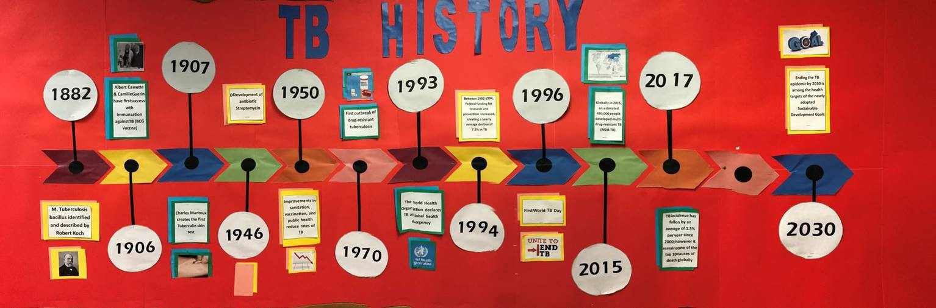

Twitter: @CTCAzeroTB

See also the new TikTok Campaign materials posted to the World TB Day Resource page in the www.ctca.org/toolkit

