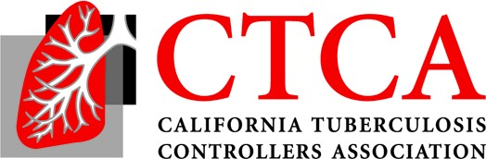
2021 Fall Education Meeting
Noon-2 PST, Friday, November 5

Agenda (9/10/21 Draft)

12:00 I. Welcome
12:05 II. The impact of COVID on TB in California, nationally and globally?

12:30 III. From pyrosequencing to targeted next generation sequencing - What does it mean for Californian clinicians?

12:45 IV. Zenni X Trial MDR
1:00 V. San Francisco Innovations
- Short course treatment implementation:
- Study 31 – CA Implementation, Janice Louie and Rocio Agraz-Lara
I: 40 VI. Arrivers from Afghanistan, Overview of Process and Impact on TB? DGMQ: Drew Posey?
Sacramento 1825 Stanislaus 222 San Diego 208 Los Angeles 194
Alameda 166 Contra Costa 111 Orange 28 San Bernardino 15
Santa Clara 13

2:00 Adjourn

