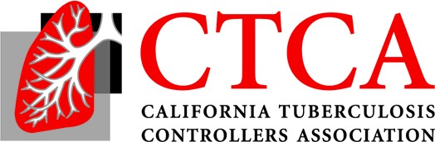
2021 Mini-Virtual-Conference
Noon-2 PST- Friday, November 5

Agenda (10/06/21 Draft)
12:00 I. Welcome, CTCA President-Elect Sundari Mase, MD, MPH, Health Officer and TB Controller
12:05 II. COVID/TB: Case Intersection, Outcomes, Impact of COVID on TB
Scott Nabity, MD, CDC Medical Officer, California Department of Public Health (CDPH)
Tuberculosis Control Branch (TBCB)

12:45 III. BPaL, Short Course Treatment for MDR TB, ZeNix and PRACTECAL trials
Pennan Barry, MD, MPH, Surveillance & Epidemiology Section Chief, CDPH TBCB

1:00 IV. San Francisco Department of Public Health Population Health Division, Disease
Prevention and Control, Tuberculosis Control Study 31 CA Implementation Process
Janice Louie, MD, Medical Director and Rocio Agraz-Lara, MSN, RN, PHN, Nurse Manager

I: 30 V. Report on the U.S. Health Screening of Afghans during Operation Allies Welcome Resettlement and the potential impact on public health TB control programs, Faculty TBD

2:00 Adjourn

