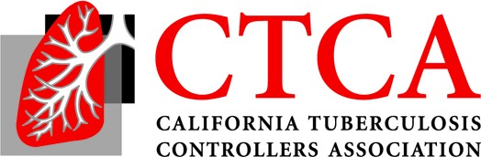
2021 Fall TB Controllers Meeting
Noon-2 PST- Friday November 19

Agenda (9/10/21 Draft)
12:00 I. Welcome, Review of Agenda, Items from the floor
12:10 II. Business Items:
- Current EC Roster
- 2019 Fall TB Controllers Meeting Draft Minutes – Voting Item
- Next Meeting: January 2021 All TB Controllers Call

12:30 III. TBCB Items
- COVID/TB: case intersection, outcomes – 30 min
Scott Nabity
- Findings of most recent CA survey - impact of COVID on TB – 10 min
Scott Nabity
- New revised RVCT implementation– 15 min
Pennan Barry
- Equity and TB - equity initiative– 15 min
Lisa Pascopella and Araxi Polony
- Revised resources and website for civil surgeons/ linkage to care- 15 min
Chris Keh, Sekai Smarr, LeiAnne Keuth
- TB Elimination Plan 2021-2025- progress – 10 min
Jennifer Flood
1:45 Open Discussion
2:00 Adjourn

