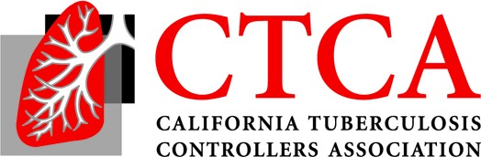

2021 Fall TB Controllers Meeting - Friday November 19, Noon-2 PST
Agenda (11/18/21 revision)
12:00 I. Welcome and Review of Agenda, Sundari Mase, MD, MPH, CTCA President-Elect, Health Officer and TB Controller, County of Sonoma Department of Health Services, Public Health Division
12:10 II. Business Items:
- Current EC Roster
- Vote: 2020 Fall TB Controllers Meeting Draft Minutes
- Next Meeting: January 2021 All TB Controllers Call
- Guidelines Prioritization Discussion

12:30 III. TBCB Items
- New Revised RVCT Implementation, Pennan Barry, MD, MPH – 15 min
- Equity and TB - Equity Initiative, Lisa Pascopella, PhD, MPH and Araxi Polony, BA – 15 min
- Revised Resources and Website for Civil Surgeons/Linkage to Care, Chris Keh, MD, Sekayi Smarr, BS, and LeiAnn Keuth, MPH - 15 min
1:15 CureTB Database System, Carlo Vera, MD, CureTB Coordinator, CDC/DGMQ/US-Mexico Unit
1:30 Open Discussion
2:00 Adjourn

